SCHOOL: - RUBY SPRINGFIELD COLLEGE
NAME: - SARAH MUSA BALAMI
CLASS: - JSS3A
S/N: - 38
ASSIGNMENT: - COMPUTER PROJECT.
QUESTION? USING CISCO PACKET TRACE AND EXPLAIN WITH STEPS AND AID TO A DIAGRAM HOW THE TOPOLOGY IS ACHIEVED.

​Cisco Packet Tracer is a cross-platform visual simulation tool designed by Cisco. Think of it as a "sandbox" where you can build, configure, and troubleshoot network topologies without needing thousands of dollars’ worth of physical hardware.
Topology: We'll create a simple network with two routers, two switches, and four PCs. The topology will be a star-bus hybrid topology.
​Core Components of Packet Tracer
​To understand how it works, you need to look at it in three main parts:
​The Logical Workspace: This is your "canvas." You drag and drop devices (routers, switches, PCs) here and connect them with cables.
​The Device Catalog: Located at the bottom left, this is where you find your gear—everything from Cisco 2911 routers to Io T devices like smart light bulbs.
​The CLI (Command Line Interface): This is the heart of the tool. When you click on a router, you get a terminal that looks and acts exactly like a real Cisco IOS (Internetwork Operating System) console.
​How to Build a Basic Network
​If you were to start a lab right now, here is the standard workflow:
​Select Devices: Grab two PCs and a Switch.
​Connect Them: Use the Copper Straight-Through cable (the solid black line) to plug the PCs into the Switch.
​Configure IPs: Click on each PC, go to the "Desktop" tab, and assign an IP address (e.g., 192.168.1.1 and 192.168.1.2).
​Test Connectivity: Open the Command Prompt on PC1 and type ping 192.168.1.2. If you see a reply, your virtual network is alive.
​Pro Tip: If the lights on your cables are orange, the switch is still thinking (Spanning Tree Protocol). If they are green, you're good to go. If they are red, something is physically wrong or the interface is "shutdown."
​Would you like me to walk you through the steps to configure a basic Cisco Router using the Command Line?

When you talk about a "Cisco trace," you're likely referring to trace route. It’s the networking equivalent of a breadcrumb trail that shows you exactly which routers (hops) your data passes through to reach a destination.
​Here is the step-by-step breakdown of how a Cisco device performs a trace, using the TTL (Time to Live) mechanism to map the path.
​The 10 Steps of a Cisco Trace route
​The Initiation: You enter the command trace route [IP or Domain] on your Cisco router or switch. The device prepares to send a series of "probe" packets (usually UDP on Cisco, though it can use ICMP).
​Setting TTL to 1: The router creates the first packet and sets its TTL (Time to Live) value to 1. This is the most important part of the trick.
​The First Hop: The packet hits the very first router in the path. That router looks at the TTL, sees it's 1, and decrements it to 0.
​The "Time Exceeded" Message: Because a router cannot forward a packet with a TTL of 0, it drops the packet and sends an ICMP "Time Exceeded" message back to your device.
​Logging the First Router: Your Cisco device receives that "Time Exceeded" message, looks at the source IP, and logs it as Hop 1. It also calculates the Round Trip Time (RTT) based on how long that took.
​Incrementing to TTL 2: Your device now sends a new packet, but this time it sets the TTL to 2.
​Passing the First Gate: The first router decrements the TTL from 2 to 1 and passes it along. The second router then receives it, decrements it to 0, and drops it.
​Mapping the Second Hop: The second router sends back an ICMP "Time Exceeded" message. Your device logs this as Hop 2.
​The Loop Continues: This cycle repeats. Your device keeps sending packets with an ever-increasing TTL (3, 4, 5...) to "peel back" the layers of the network and identify every router in the chain.
​Reaching the Destination: Once the packet finally reaches the actual destination (e.g., a web server), the destination doesn't send a "Time Exceeded" message. Instead, it sends an ICMP Port Unreachable or an Echo Reply. This tells your device the journey is over, and the trace stops.
​What to Look For in a Trace
​Asterisks (* * *): This means a router timed out. It’s either too busy or, more likely, configured to ignore trace requests for security.
​High Latency: If the time jumps from 10ms to 200ms between two hops, you’ve found exactly where the network bottleneck is.
​Fun Fact: On a Windows PC, the command is tracer, but on Cisco and Linux, it’s the full word trace route. If you type tracer into a Cisco router, it’ll just stare at you blankly.

Devices:
- 2 x Routers (R1 and R2)
- 2 x Switches (S1 and S2)
- 4 x PCs (PC1, PC2, PC3, and PC4)
Step-by-Step Instructions:
1. Launch Cisco Packet Tracer: Open the application and select "New" to create a new project.
2. Add Devices:
- Drag and drop the following devices onto the workspace:
- 2 x Routers (R1 and R2)
- 2 x Switches (S1 and S2)
- 4 x PCs (PC1, PC2, PC3, and PC4)
3. Connect Devices:
- Connect the devices as follows:
- R1 to S1 (GigabitEthernet0/0 to FastEthernet0/1)
- S1 to PC1 (FastEthernet0/2 to FastEthernet0)
- S1 to PC2 (FastEthernet0/3 to FastEthernet0)
- R2 to S2 (GigabitEthernet0/0 to FastEthernet0/1)
- S2 to PC3 (FastEthernet0/2 to FastEthernet0)
- S2 to PC4 (FastEthernet0/3 to FastEthernet0)
- R1 to R2 (GigabitEthernet0/1 to GigabitEthernet0/1)
4. Configure IP Addresses:
- Configure the IP addresses for each device:
- R1: 192.168.1.1/24 (GigabitEthernet0/0)
- R2: 192.168.2.1/24 (GigabitEthernet0/0)
- PC1: 192.168.1.10/24 (Default Gateway: 192.168.1.1)
- PC2: 192.168.1.11/24 (Default Gateway: 192.168.1.1)
- PC3: 192.168.2.10/24 (Default Gateway: 192.168.2.1)
- PC4: 192.168.2.11/24 (Default Gateway: 192.168.2.1)

5. Configure Routing:
- Configure static routing on R1 and R2 to allow communication between the two networks.
Diagram:
Here's a simple diagram of the topology:

+-----------------------+
| R1 |
| 192.168.1.1/24 |
+-----------------------+
|
|
v
+-----------------------+
| S1 |
| |
| PC1 (192.168.1.10) |
| PC2 (192.168.1.11) |
+-----------------------+
|
|
v
+-----------------------+
| R2 |
| 192.168.2.1/24 |
+-----------------------+
|
|
v
+-----------------------+
| S2 |
| |
| PC3 (192.168.2.10) |
| PC4 (192.168.2.11) |
+-----------------------+

Testing:

- Use the "Simulation" mode in Packet Tracer to test the connectivity between devices.
- Ping PC1 to PC3 to verify that the routing is working correctly.

​
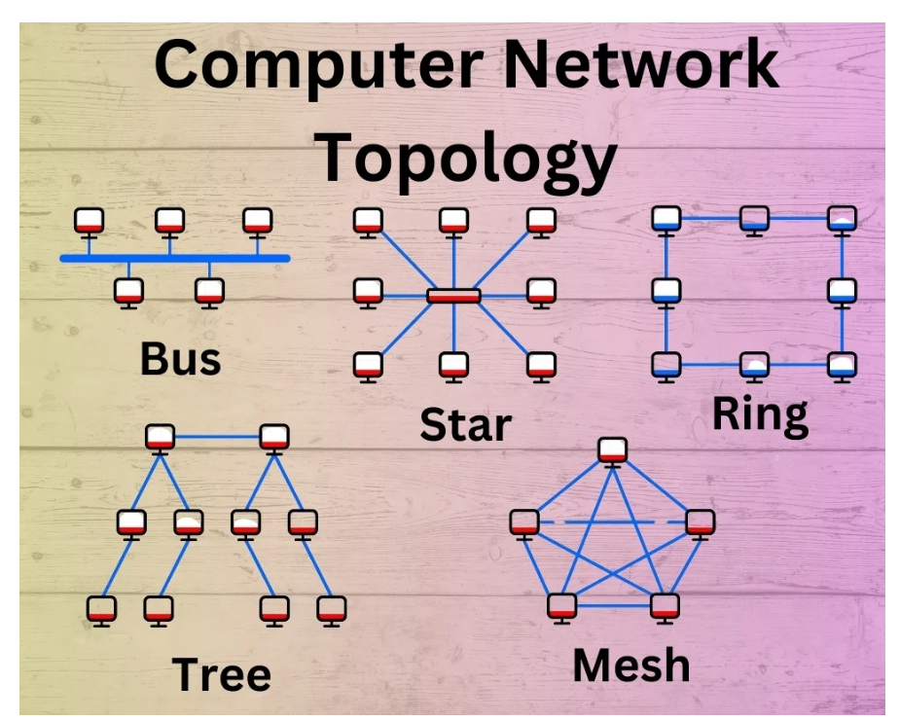

REFERENCE:-
1. "Cisco CCNA Routing and Switching Complete Study Guide" by Todd Lammle
2. "Network Warrior" by Gary A. Donahue
3. "Cisco Networking Essentials" by Rick McDonald

